ST FRANCIS DE SALES CATHOLIC INFANT AND NURSERY SCHOOL
“we walk, learn, love and smile together with Jesus”
NEWSLETTER 25th JUNE 2021
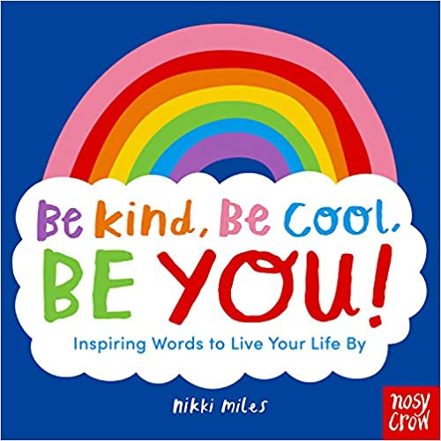
Dear Parents/Carers,

On-line Safety
Following an increasing number of incidents and concerns reported by class teachers please read the following message from School Improvement LIverpool:
It is vital parents and carers actively monitor what their children are viewing online in order to protect them and also to ensure their child’s own behaviours are appropriate.
Parents and carers should ensure ‘parental settings’ are in place not just on smartphones but also on any device that connects to the internet.
Merseyside Police recently shared the following message with the whole community:
“We would strongly advise parents to be satisfied that they know who their children are engaging with, be that via social media or through gaming on Xboxes and PlayStation and want to raise awareness of the importance of setting parental controls on computers, games consoles and electronic devices to keep children safe, so they are not exposed to potentially harmful and inappropriate material online.”
Guidance about parental controls can be found here:
Internet Matters - parental controls NSPCC – parental controls
Attendance
Our next attendance initiative starts on Monday with rewards, fun and football skills on offer for classes with good or improved attendance or for individual children with 100%. Please try and bring your children into school as they miss so much fun and learning when they take odd days off. If your child is off school with a Covid related illness this does not affect their attendance percentage. There are 3 weeks left before the Summer break and the children will be involved in many different activities, including meeting their new teachers (via zoom again unfortunately), sports days (see below for dates), leavers Mass (for our Year 2 children who will be moving onto the Junior school) and this year’s unique take on the Summer Fair! Singing practise is well under way and we can’t wait to celebrate the end of the year with each class. Here are the figures for this week:

Group | Percentages
ASPEN | 97.2
SYCAMORE | 91.2
CEDAR | 85.9
ELM | 92.6
WILLOW | 90.7
MAPLE | 88.7
ASH | 99.3
LAUREL | 97.7
OAK | 95.5
HOLLY | 100
SILVER BIRCH | 96.5
Totals | 94.1
Holly class have received treats today as a reward for 100% - well done. Ash class well done also fabulous.

Sports Day Dates
The children should come to school in sports wear on this day – please check the dates carefully as it may not be their usual PE day. Sadly, we cannot allow parents to attend but will get photographs and videos onto the website and Seesaw as soon as we can. We are sure the children will be keen to tell you all about it.

Monday 28th June – Reception
Tuesday 29th June– Year 1
Wednesday 30th June – Nursery
Friday 2nd July – Year 2

Science Fun Day
The fabulous sounds of laughter, ooooh’s and arrrr’s filled the classrooms yesterday as numerous science experiments were held – from rainbow skittles (interesting) to Mr Turner’s infamous baking soda rockets (sadly not much luck this year Mr. T!) to levitating water, dunking biscuits, hover-crafts and yes Reception really did make ice-cream in 6 minutes with ice and milk!! Check out the website for lots more pictures.

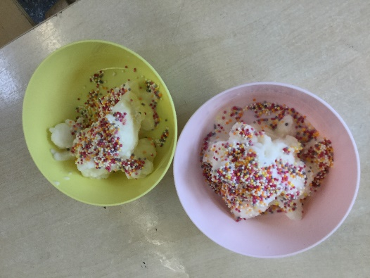
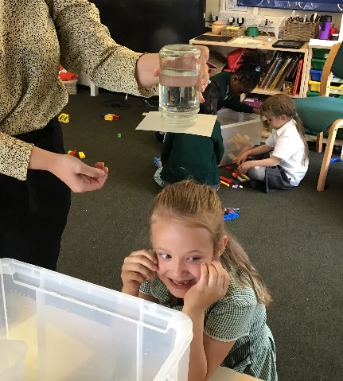

“I loved science day and all the different experiments we did. The best bit was when we poked a pencil through a bag of water and the water didn’t come out!” Wow, thanks Sophie (Reception). If you try this at home it has to be a ziplock bag! For all you budding scientists out there! It’s something to do with the chain of molecules that make up polymer!

SEND - Virtual Coffee Morning

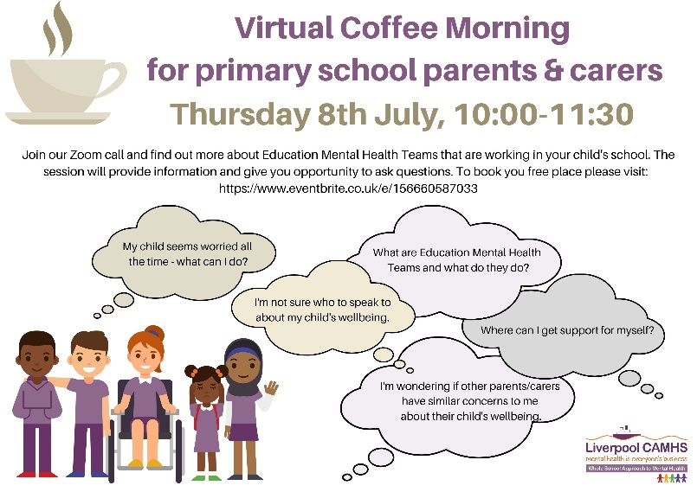

Covid
As many of you know we have had a number of cases of Covid within school over the past two weeks which I know will be concerning for many of you. This has resulted in class bubbles having to go home and self-isolate. We kindly request that if you one of your children are asked to self-isolate, you do not then go out into the community with them. We have heard numerous families are taking this as an opportunity to go away or have play dates with friends. This will only result in the virus spreading further. As always we have your child’s education at the heart of all we do and do not want this to keep recurring. Learning continues for classes self-isolating via our Seesaw app.

Please adhere to the guidance given and please stick to our usual rules on the playground – wear a face mask if you can, stick to our one-way system and keep your distance. We also kindly ask that parents are polite and respectful to members of our school staff when asked to stick to these rules.

Thank you and have a lovely weekend everyone.

L Melia

Headteacher

